MEDIA ADVISORY
FOR IMMEDIATE RELEASE

Steel leaders from India, Japan and South Korea focused on green transition

SEOUL, KOREA (August 18, 2022) – Steel industry leaders from India, Japan and South Korea will discuss strategies and policies to accelerate the transition to green steel. As one of the most carbon intensive industries, the need for Asian steelmakers to commit to decarbonization comes at the most vital and crucial time amid worsening climate records and disasters all over the world.

This conference is the first of its kind in Asia and is part of larger efforts to build momentum required for a green steel transition, under the UNIDO-coordinated Industrial Deep Decarbonization Initiative (IDDI). The initiative seeks to create opportunities to set ambitious green procurement targets for steel while working towards lowering carbon emissions and pivoting to new technologies.

Steel production is among the world’s most carbon intensive industries, making up some 8% of the world’s carbon emissions. This is because in traditional steelmaking, the highly energy-intensive process requires fossil fuels such as coal and gas. In addition, steel demand is on the rise as a major building block of the global economy. To reduce emissions, the steel sector must quickly transition to green steel.

The Asian steel industry produces the largest share of all steel globally, with some 70% of all crude steel being produced in Asia. With India, Japan and South Korea all being leading steel producers, they play a pivotal role in decarbonizing steel.

Globally, governments are pledging corporate net-zero commitments but at the current speed of the steel sector, carbon neutrality will be virtually impossible to achieve by 2050. An immediate shift to low-carbon steel manufacturing is imperative for countries to uphold their promises.

Next Monday on August 22, 10:00 KST, local and global stakeholders in the steel sector, including high-profile industry leaders, policymakers, and research think tanks to address steel decarbonization. Some attendees include Samsung, POSCO and Korea Shipbuilding & Offshore Engineering. These leading experts will exchange ideas and examine the current obstacles as well as opportunities available for their respective regions in order to rapidly decarbonize the steel sector, including green public procurement (GPP) and private procurement, assessing the impact of GPP through case studies in the three countries.

This event is co-organized by Climate Catalyst and Solutions for Our Climate (SFOC). The event is open to the media.

WHAT: Trilateral Industry-Policy Dialogue on Accelerating Steel Decarbonization in Asia

WHERE: Online, register here
WHEN: August 22, 2022, 10:00 KST
LANGUAGE: English, Japanese and Korean (simultaneous translations will be provided)

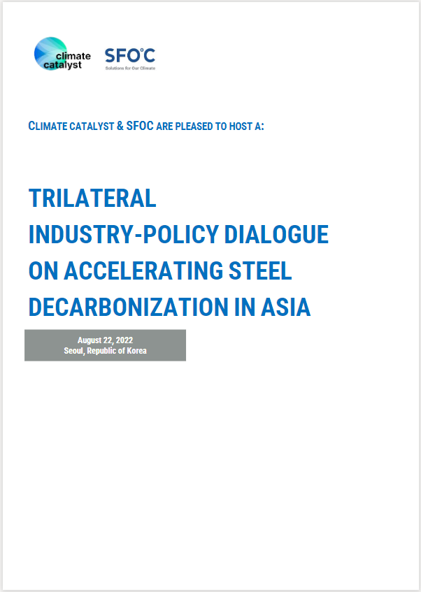

Media Contact:
Joseph Kim
Communications Officer
joseph.kim@forourclimate.org

